100 Times Faster!!
Benjamin Bor
CMG (Computer Management Group) UK
1 Abstract
At first glance, the task seemed impossible. A very large scheduling system had been developed by a competitor software house for an international oil company. Once the users commenced Acceptance Testing it became apparent that the performance was hopeless: a ‘drag and drop’ operation would take 5 minutes. The ‘daily run’ would take over 40 hours. In short, the system was suffering from the ‘HHGTTG’ syndrome.
We were asked to find out whether the project was a ‘throw away’, or if severe measures could salvage the huge development investment.
The nature of sophisticated scheduling systems means that large amounts of data have to be examined in order to find the optimum schedule. Our task was to find a solution that could deliver this amount of data in a timely manner without compromising the functionality and the integrity of the system.
The solution we developed was a combination of squeezing the last drop of performance out of Oracle and developing our own caching and hashing mechanism on top of Oracle.
This presentation will describe both approaches and how we combined them to achieve outstanding performance gains.
The audience can expect to:
- Get an insight to the ‘standard’ approach to ‘acute’ performance tuning
- Learn some performance tips and tricks
- Become aware of some ‘classic’ pitfalls
- Learn about some specific mechanisms we developed, which although not generally recommended, may spark the imagination
- Learn to apply ‘Ben’s Recipe for Performance’
The presentation will briefly outline the system, portray the main data management challenges and describe the performance enhancement approach. General as well as specific performance techniques will be discussed.
2 The System
The system is a scheduling system. Basically, it looks at a set of vehicles, roads and orders and calculates the cheapest schedule (a set of trips) that will deliver the orders using the vehicles.
If this is so simple, why is it so complex?
To start with, the problem of finding the cheapest route between N nodes is an NP-complete problem, very similar to the famous ‘Travelling Salesman’ problem.
But the main complexity, at least from the Data Management point of view, is that of representing constraints. Since the system is to be deployed all over the world, it had to be able to model a myriad of constraints. For example, some vehicles can not use some roads; some drivers can not drive some vehicles; Some vehicles can not carry some products; Some drivers may not serve some customers; and so on and so on. A basic requirement of the system is that the constraints are ‘soft coded’ (e.g. the users can decide to add new constraint groups).
Another complexity is the definition of margins: An order is an agreement to purchase specific quantities of some products. However, orders allow for a variation in these quantities, within given limits. The system has to balance the tradeoff between delivering optimum schedules and varying from the required product quantities.
Let’s look at a real-life example:
2.1 Scheduling Example
Why won’t you try your hand at scheduling? How would YOU schedule this scenario?

Vehicle availability and cost
Vehicle  ID | Capacity  (litres) | Cost  (cents per KM)
A | 8100 | 29
B | 10800 | 30
C | 18200 | 33
D | 18900 | 34
Orders
Customer  ID | Quantity
C1 | 8100 litres
C2 | 10800 litres
C3 | 18900 litres
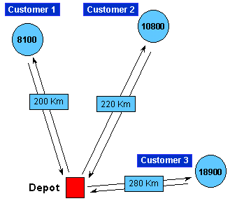
Order variation allowed: 20%

Most people would go for the obvious solution shown above: Send vehicle A to C1, vehicle B to C2 and vehicle D to C3.
This entails a travel distance of 200+220+280 = 700 km, at a cost of (200 x 29) +(220 x 30) +(280 x 34) = $219.20.
The scheduling system would solve it as follows:

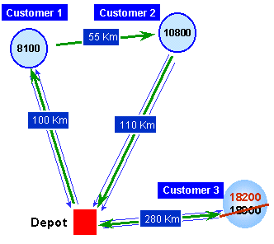
Vehicle D is filled to capacity and travels to customer 1 with 8100 litres, continues to customer 2 with 10800 litres and returns to the depot. Vehicle C takes its maximum load of 18200 litres and delivers it to customer 3. This falls within the allowed 20% variance.
This entails a travel distance of 100+55+110+280 = 545 km, at a cost of (265 x 33) +(280 x 34) = $182.65.
This solution saves 155 km and $36.55 (16.7%).
3 The Recipe for Good Performance
This approach to performance is based on understanding how Oracle operates, which of the tasks may become bottlenecks, and what can be done to minimize these.
3.1 What Takes Time?
Let us consider what Oracle does when performing your query:
For a read-only query, Oracle has to:
- ‘Compile’ the query
- Locate the relevant data pages
- Load them into memory
- Extract the data records from the pages
- Perform any manipulations required
- Sort or aggregate
- Format the results
- Transfer the data to the requesting client
For an Update query:
- All the above, plus
- Allocate space
- Check constraints
Note that the actions described above may be recursive: locating data pages may require locating index pages which may require locating system pages. Inserting a row may require inserting an index which may require allocating an extent which may fire a trigger and so on.
3.1.1 Reading the Data
Oracle never reads your data directly from the disk! Oracle identifies the address for the page that holds your data. If that page is in memory, Oracle searches that page for the required data. If not, Oracle has to load the page into memory. This is true for all pages, including data, index and system pages.
The speed of reading a page from disk and the speed of finding a page in memory depend on the configuration. Nevertheless, a useful guideline is to assume that disk access is about 100 times slower than memory access.
3.2 What Can You Do?
The main impact you can have on performance is by minimizing the number of pages that Oracle has to examine. Even more important, minimize the number of pages that are accessed from the disk.
4 Ben’s Recipe for Performance
Ingredients
1 badly performing database system
1 highly knowledgeable DBA
2 oz patience
Memory according to taste
(Un)Common sense – if in season. Otherwise, use lots of hardware…
Method
- Don’t panic!
- Document your performance expectations
- Allocate to the SGA as much physical memory as you can afford.
- Optimize the indexes:
  - Ensure that the primary keys are indexed
  - Consider indexing foreign keys
  - Consolidate single-column indexes to composite indexes, where sensible
  - Remove redundant indexes
  - Recreate old indexes
  - Tune the %Free on indexes
  - Consider index covering – getting the result set from the index
  - Consider indexes to avoid sorting
- Find out the problematic queries (using TRACE)
- Fine-tune the problematic queries
  - Re-write SQL to improve efficiency
  - Use PL-SQL to avoid rescanning data
  - Consider changes to the database – redesign or de-normalization
  - Use ‘Explain Plan’ to ensure optimal usage of indexes
- Consider moving logic to stored procedures on the server (especially for WAN systems)
- If this is not enough, rethink your strategy. Are your expectations realistic? More drastic measures may be required (as was the case of the system described here).
5 Common Pitfalls
The following is a partial list of common pitfalls that may affect performance
5.1 Data Manipulations Prevent Index Usage
Oracle will not use an index for
…WHERE TABLE1.KEY_COLUMN + 1 = 7
But will use an index for
…WHERE TABLE1.KEY_COLUMN = 6
5.2 Inconsistent Data Types
When the query equates two columns of different data types, Oracle attempts to convert one of them to the data type of the other. Since data conversion is a manipulation, this may cause Oracle to not use the index that exists on the converted column. The query looks innocent, you wonder why an index is not being used, but until you look at the column definition, the reason is not clear.
5.3 Functions
It is very tempting to develop a set of functions that can be selected in a query in a way that will hide some of the schema complexity from the developers. Be aware that Oracle compiles the functions separately to the queries that call them. This means that if you have a query that calls two functions that traverse the same path, the path will be traversed twice. For example, fn_tel_no finds the telephone number for a given customer, using a five-table join. Fn_fax_no uses exactly the same logic to find the fax number.
The query
SELECT customer_id,
fn_tel_no( customer_id ) tel_no,
fn_fax_no( customer_id ) fax_no
FROM customers
will perform the five-table join twice!
5.4 Data Dependency
The performance of your queries may vary greatly with the data contents. A common mistake is to tune the query to perfection using non-realistic data and expect good performance when the query runs in the real world.
6 Non-standard Techniques Used on this Project
From the onset it was obvious that the performance targets could not have been achieved without special purpose built mechanisms. This chapter describes some of the more interesting mechanisms deployed.
6.1 Memory Resident Flags and Data Items
A complicated system may use the same data repeatedly for different purposes. In our case, we found that user-specific characteristics were used by many of the programs. We created a package with global data fields and ran a start-up procedure at login time that loaded these data fields. We then modified the system to use the values from the global fields, instead of querying the database tables.
6.2 Purpose Built Caching
We monitored the scheduling engine and found that in order to calculate a reasonably simple schedule it hit the ROUTES table 7,000,000 times. Since the table was expected to have around 500,000 records, it was unreasonable to expect this to finish in minutes (if each query takes 1/10 of a second, the whole thing would take about 200 hours!). The solution here was to construct a purpose-built route cache that can supply the data a lot faster. We built (using C++) a hashed list of all the routes. The hashing mechanism allowed us to perform thousands of route queries per second.
The nature of scheduling dictates that changes to one task in the schedule can affect many other tasks on the schedule. For example, removing one delivery from a schedule requires recalculation of all the following deliveries. In order to ensure that ‘drag and drop’ functionality is quick we built a linked-list cache for the data structure describing a schedule. Queries regarding the current schedule could be answered from the cache a lot faster than Oracle would be able to perform them.
6.3 The ‘Changed Tables’ Table
The purpose-built caching mechanism described above posed a new problem: One user may hold data in cache while another user is changing it. We needed a mechanism that would refresh the cache periodically, if required. The original developers used Oracle’s auditing for that: they set row level auditing up. At specific points in the application they would query the audit table to find out the latest modification date for the tables that were cached. The query would look something like
SELECT table_name, MAX(modification_date)
FROM audit_table
GROUP BY table_name
This query may look innocent enough, but our audit table grew very rapidly. It could have as many as 1,000,000 records at the end of a day, and the above query would take minutes.
Our solution was to create a new table, holding one row for every table we were interested in. The row held the table name and last time the table had been modified. This new table was updated by every Insert, Update and Delete trigger on the system. We calculated that the table occupies one or two Oracle pages. It was accessed frequently and therefore was almost certain to be in memory when required. This improved performance of the above query from minutes to sub-second, but added a small overhead to each Insert/Update/Delete operation.
6.4 Generic Vs Traditional Modeling
The system was originally designed using the ‘Generic Modeling’ technique (which is described in detail in another paper titled ‘Generic Modeling’). The diagram below compares the ‘traditional’ approach with the ‘generic’ approach for a simple case. Without going into detail, it is obvious that in this case the complexity of the system, and subsequently the complexity of the queries involved, are higher in the Generic model as compared to the ‘Traditional’ model.
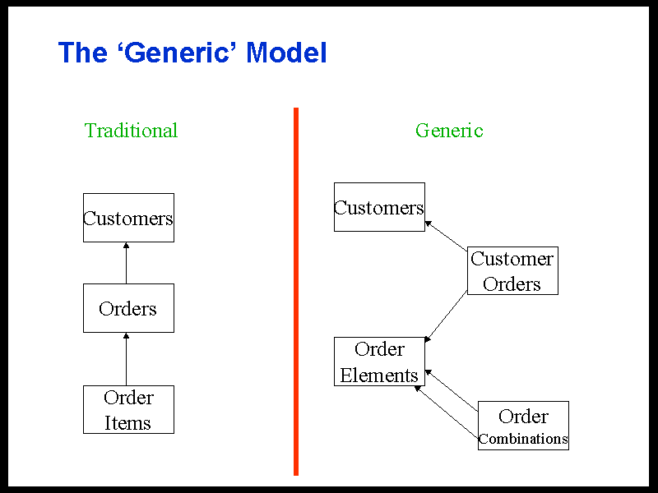
We spent a substantial amount of time and effort changing the database design back to ‘traditional’. This proved to improve the system performance considerably.

7 Summary and Conclusions
- The performance of the system improved dramatically. The ‘drag and drop’ operation down from 5 minutes to 4 seconds. A typical ‘scheduling run’ down from 40 hours to 20 minutes. Average time to upload an order down from 150 seconds to 0.8 seconds.
- The system is in production in three countries and others are awaiting implementation.
- In a single country, the system can save over £1M per year over manual scheduling.
- A performance improvement program should start with the standard approach, as described in ‘Ben’s Recipe for performance’ before considering more drastic measures.
- The main performance gains can be achieved by
- Utilizing memory
- Minimizing the number of data pages accessed
- For WAN systems, minimize the amount of data transferred on the net

I would welcome your comments, suggestions, questions or views. Please E-mail me at Ben.Bor@CmgPlc.com.

HHGTTG Syndrome: you make a query, the computer thinks for about a million years and comes up with the correct answer, 42.
The complexity of NP-complete problems increases exponentially with the number of data items.
This is a good advice if your system suffers from the HHGTTG syndrome. And if you haven’t got it by now, HHGTTG stands for the ‘Hitch Hiker’s Guide To The Galaxy’…

