Performance Tuning - Now You are the V8 Expert
Richard J. Niemiec
TUSC
Abstract:
Version8 of the Oracle database has brought on a whole new level of issues for the DBA. While the queries for tuning the database and individual queries has not changed much, the data retrieved by these queries has changed and must be analyzed for partitioned tables and other cost-based optimizer functions. This paper will serve to give you the individual queries to be successful. These excerpts come from the book, Oracle Performance Tuning Tips and Techniques (Oracle Press (900 pages): ISBN 0-07-882434-6). Oracle is a symphony and you are the conductor with an opportunity to create a world class performance. As with an orchestra, there are many different sections that must be coordinated with perfection if you are to succeed. Each chapter in the book represents a section of the orchestra which must be tuned. A single query (a single note) or a poorly configured init.ora (the violin section) can be the cymbals (the ad-hoc query user) that will crash at an inopportune time to bring your system to its knees. The key to tuning often comes down to how effectively you can tune the database memory and single problem queries. This paper will touch on as much as possible, but the book is 900 pages with much more of a solution to tuning Oracle7, Oracle8 and Oracle8i.

What will be Covered (Goals for tuning):

Goal#1: Have enough memory allocated to Oracle - The first goal should be to get enough memory (from your physical hardware) allocated to “key” Oracle parameters. We will look at how to see what the current settings of a given system are set to and also look at the “key” parameters: DB_BLOCK_BUFFERS, SHARED_POOL_SIZE, and SORT_AREA_SIZE.
Goal#2: Get the data loaded into memory - Once you have enough memory allocated to Oracle, the focus must shift to ensuring that the most important information is getting into memory and staying there. We will look at using x$bh and using the ‘cache’ parameter of ‘alter table...’ to investigate this area.
Goal#3: Find queries that are clogging memory and causing I/O - Finding problem areas is, at times, the most difficult problem. We will investigate a method for easily identifying the bottlenecks by using v$sqlarea.
Goal#4: Tune the Problem Queries - Tuning the problem queries could easily encompass an entire training course. I will focus on the a couple of key areas: What you need to know before you tune my system, using the Parallel Query Option and general tuning tips.

Goal#1: Have enough memory allocated to Oracle

Even if the system that you are working on has 10 Gig of memory available, this doesn’t help much if only a small portion of it is allocated to Oracle. We allocate memory to Oracle through the INITsid.ORA file. Some of the key parameters are listed below. We will cover each of these parameters in the following sections. By going to “v$parameter” or by using the either Server Manager or Oracle Enterprise Manager, we can find the parameters that affect Oracle’s performance.

A. Finding the values of ‘KEY’ INIT.ORA parameters:
select name, value
from v$parameter
where name in (‘db_block_buffers’, ‘db_block_size’, ‘shared_pool_size’, ‘sort_area_size’);

NAME VALUE
-------------------------------------------------- --------------------
db_block_buffers 4000
db_block_size 4096
shared_pool_size 7000000
sort_area_size 262144
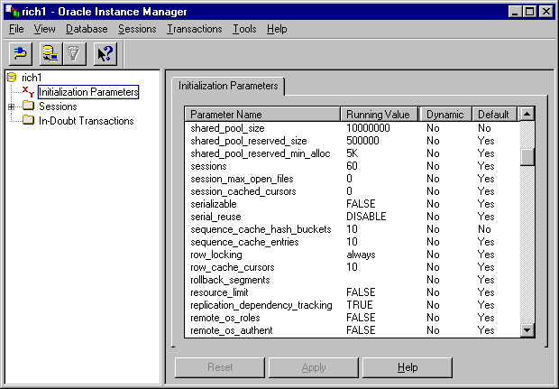
You can also view the init.ora parameters in Oracle’s Enterprise Manager as shown below:

V8 Tip: The allowable db_block_size has increased in Oracle8 to be 32K. Remember that changing the block size can only be accomplished by rebuilding the database.

B. Look at DB_BLOCK_BUFFERS:
The first parameter to look at is the INITsid.ORA parameter: DB_BLOCK_BUFFERS. This is the area of the SGA that is used for the storage and processing of data in memory. As users request information, the information is put into memory. If the DB_BLOCK_BUFFERS parameter is set too low, then the least recently used data will be flushed from memory. If the data flushed is recalled with a query, it must be re-read from disk (causing I/O and CPU resources to be used). If DB_BLOCK_BUFFERS is too low, users will not have enough memory to operate efficiently. If DB_BLOCK_BUFFERS is too high, your system may begin to swap and may come to a halt.
Determine if the data block buffers is set high enough:
select 1-(sum(decode(name, 'physical reads', value,0))/
(sum(decode(name, 'db block gets', value,0)) +
(sum(decode(name, 'consistent gets', value,0))))) * 100
"Read Hit Ratio"
from v$sysstat;

Read Hit Ratio
98.415926
Although hit ratios below 90-95% are usually a sign of poor indexing; Distortion of the hit ration numbers is possible. See the next section for more information.
Response Time in Minutes
Figure 1: Response Time for a Memory Intensive Report with given SGA (Buffer) settings

Hit Ratio Distortion:
Even though the equations for finding a problems seems easy, sometimes the results are not accurate. Many third party products also receive this misinformation, yet some go to other areas to get the correct information. Below, I show one such case where misinformation is returned.
There are also false hit ratio distortions. SQL*Forms can cause a false high hit ratio, rollback segments can cause a false high hit ratio impact and indexes can have hit ratios as high as 86% when none of the blocks were cached prior to the query executing.
C. It is important to look at the SHARED_POOL_SIZE for proper sizing
With a greater amount of procedures, packages and triggers being utilized with Oracle, the SHARED_POOL_SIZE makes up a much greater portion of the Oracle SGA. This is the memory allocated for the library and data dictionary cache. If the SHARED_POOL_SIZE is set too low then you will not get the full advantage of your DB_BLOCK_BUFFERS.
Determine dictionary cache miss ratio:
select sum(gets) “Gets”, sum(getmisses) “Misses”,
(1 - (sum(getmisses) / (sum(gets) +
sum(getmisses))))*100 “HitRate”
from v$rowcache;

Gets Misses HitRate
10233 508 95.270459
This would be a good Ratio and would probably not require action in this area.
Determine library cache hit ratio:
select sum(pins) Executions, sum(pinhits) “Execution Hits”,
((sum(pinhits) / sum(pins)) * 100) phitrat,
sum(reloads) Misses,
((sum(pins) / (sum(pins) + sum(reloads))) * 100) hitrat
from v$librarycache;

Executions Execution Hits PHITRAT Misses HITRAT
3,582 3,454 96.43 6 99.83
Tip: If the hit ratio or reloads is high, increase the shared_pool_size INIT.ora parameter. Reloads indicate that statements that were once in memory now had to be reloaded because they were pushed out, whereas misses include statements that are loaded for the first time.

How much memory is left for SHARED_POOL_SIZE:
col value for 999,999,999,999 heading “Shared Pool Size”
col bytes for 999,999,999,999 heading “Free Bytes”
select to_number(v$parameter.value) value, v$sgastat.bytes,
(v$sgastat.bytes/v$parameter.value)*100 “Percent Free”
from v$sgastat, v$parameter
where v$sgastat.name = 'free memory'
and v$ parameter .name = ‘shared_pool_size;

Shared Pool Size Free Bytes Percent Free
100,000,000 82,278,960 82.27896

A better query:
select sum(ksmchsiz) Bytes, ksmchcls Status
from x$ksmsp
group by ksmchcls;

BYTES STATUS
350,000 R-free
40 R-freea
25,056 free
2,571,948 freeabl
4,113,872 perm
1,165,504 recr
If there is free memory then there is no need to increase this parameter.
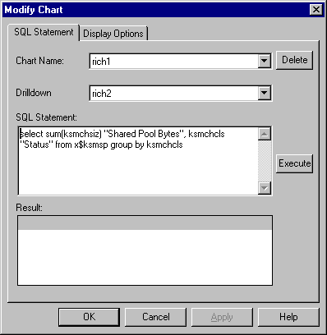
You can also view the init.ora parameters in Oracle’s Enterprise Manager as shown below. The add/modify chart and the result of this query are shown in the two displays below.

Tip: An ORA-4031 is usually caused when the shared pool gets fragmented (you’re not necessarily out of shared pool) into smaller pieces over the course of a day and a request for a large piece of memory is issued which can not be filled.
Tip: Retrieving information from memory is over 10,000 times (depending on the memory you have) faster than retrieving it from disk so make sure that the SGA is large enough
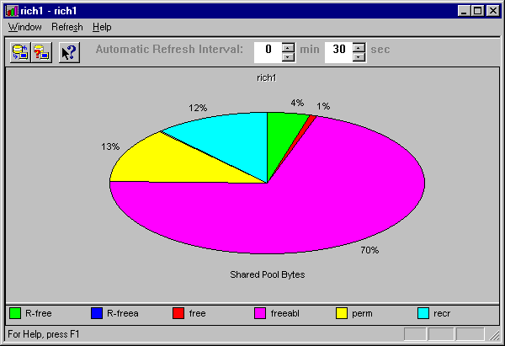
D. Try to sort in memory instead of in temporary:
The INIT.ora parameter SORT_AREA_SIZE will allocate memory for sorting (per user / as needed). This is the area that is the space allocated in main memory for each process to perform sorts. This memory will reside in the UGA section of the PGA for non-MTS (Multi-Threaded Server) and in the SGA for MTS databases. If the sort cannot be performed in memory, temporary segments are allocated on disk to hold intermediate runs. Increasing the value of sort_area_size will reduce the total number of disk sorts, thus reducing disk I/O. This can cause swapping, if to little memory is left over for other processes. Statements that will generate Temporary Segments include: Create Index, Select .... Order By, Distinct, Group By, Union, Unindexed Joins, Some Correlated Subqueries. Since temporary segments are created to handle sorts that cannot be handled in memory, the initial extent default for temporary segments should be at least as large as the value of sort_area_size. This will minimize extension of the segment.

Many parameters can be set by individual sessions (especially in Oracle8):

Alter session set sort_area_size=100000000;

Session altered.

The problem in the preceding query is the developer has granted the session the capability of using 100M of memory for a sorting in this session.

Tip: Changing init.ora parameters with an ALTER SESSION, is a powerful feature for both developers and DBAs. Consequently, a user with the ALTER SESSION privilege is capable of irresponsibly allocating 100M+ for the sort_area_size for a given session, if it is not restricted. See chapter 13 in the book for parameters that can be modified this way (this information comes from the v$parameter view).

Goal#2: Get data “cached” into memory
Once you have enough memory allocated to Oracle, the focus must shift to ensuring that the most important information is getting into memory and staying there. We will look at using x$bh and using the ‘cache’ parameter of ‘alter table...’ to investigate this area below:
A. To see how fast the SGA gets using x$bh:
select state, count(*)
from x$bh
group by state;

STATE COUNT(*)
--------- -----------------
0 371
1 429

In the above result:
Total DB_BLOCK_BUFFERS = 800
Total that have been used = 429
Total that have NOT been used = 371

A better query:

select decode(state,0, 'FREE', 1, decode(lrba_seq,0,'AVAILABLE','BEING USED'),
3, 'BEING USED', state) "BLOCK STATUS", count(*)
from x$bh
group by decode(state,0,'FREE',1,decode(lrba_seq,0,
'AVAILABLE','BEING USED'),3, 'BEING USED', state);

BLOCK STATUS COUNT(*)
AVAILABLE 779
BEING USED 154
FREE 167

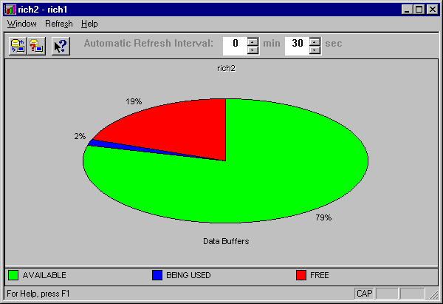
You can also view the init.ora parameters in the Performance Manager inside Oracle’s Enterprise Manager as shown below:

B. Using the ‘cache’ parameter of ‘alter table...’):
If you find that “key” tables are being pushed out of memory, you may need to “pin” them into memory using the CACHE parameter. When you use this parameter, full table scans result in being placed on the “Most recently used” list instead of the “Least recently used” list. This keeps them in memory for future use. The following examples investigate the syntax and uses of this command:
Example 1 (Create a table with CACHE):
CREATE TABLE TEST_TAB (COL1 NUMBER)
TABLESPACE USERS
CACHE;

NOCACHE is the Default!

Example 2 (Alter a table to CACHE):
ALTER TABLE TEST_TAB
CACHE;

Example 3 (The CACHE Hint):
SELECT /*+ CACHE(CUST) */ ENAME, JOB
FROM CUST
WHERE TABLE_NAME = 'EMP';

Example 4 (The NOCACHE Hint):
SELECT /*+ FULL(CUST) NOCACHE(CUST) */ ENAME, JOB
FROM CUST
WHERE TABLE_NAME = 'EMP';

You may also pin (cache) PL/SQL object statements into memory:
In the event that you cannot maintain a sufficient SHARED_POOL_SIZE, it may become important to keep the most important objects cached (pinned) in memory. The following example shows how to pin PL/SQL object statements in memory using the DBMS_SHARED_POOL.KEEP procedure. For additional PL/SQL tips see chapter 10 which focus exclusively on PL/SQL.
BEGIN
DBMS_SHARED_POOL.KEEP(‘PROCESS_DATE’,’P’);
END;

Tip: Pin PL/SQL objects into memory immediately upon starting the database to avoid insufficient memory errors later in the day. To accomplish this, use the DBMS_SHARED_POOL.KEEP procedure for PL/SQL object statements. Ensure that the STANDARD procedure is pinned soon after startup since it is so large.

You may also pin all packages:

To pin all packages in the system, execute the following (from Oracle’s Metalink):

declare
own varchar2(100);
nam varchar2(100);
cursor pkgs is
select owner, object_name
from dba_objects
where object_type = 'PACKAGE';
begin
open pkgs;
loop
fetch pkgs into own, nam;
exit when pkgs%notfound;
dbms_shared_pool.keep(own || '.' || nam, 'P');
end loop;
end;

Common “problem packages” that are shipped with Oracle (and should be ‘kept’) include 'STANDARD', 'DBMS_STANDARD', and 'DIUTIL'.

Tip: Use the DBMS_SHARED_POOL.KEEP procedure combined in PL/SQL to pin all packages when the database is started (if memory/shared pool permits) and avoid all errors involving loading packages in the future. See chapter 10 for additional PL/SQL and pinning tips.

Goal#3: Find problem queries “hurting” memory
A single index or a single query can bring an entire system to a near standstill. By using v$sqlarea, you can find the problem queries on your system. Below, the example shows how to find the problem queries. I am searching for queries where the disk reads are greater than 10,000. If your system is much larger, you may need to set this to a higher number.
Example 5 (Finding the largest amount of physical reads by query):
select disk_reads, sql_text
from v$sqlarea
where disk_reads > 10000
order by disk_reads desc;

DISK_READS SQL_TEXT
------------------ -----------------------------------------------------------------
12987 select order#,columns,types from orders
where substr(orderid,1,2)=:1
11131 select custid, city from customer
where city = ‘CHICAGO’

Example 6 (Finding the largest amount of logical reads by query):
select buffer_gets, sql_text
from v$sqlarea
where buffer_gets > 200000
order by buffer_gets desc;

BUFFER_GETS SQL_TEXT
------------------ -----------------------------------------------------------------
300219 select order#,cust_no, from orders
where division = ‘1’

You may need to join to the v$sqltext view:
You may have to join in the v$sqltext table to get the full text since v$sqlarea only shows a portion of the SQL_TEXT. See chapter 4 for a detailed look and analysis of the example the query below.

Break on User_Name On Disk_Reads on Buffer_Gets on Rows_Processed
Select A.User_Name, B.Disk_Reads, B.Buffer_Gets,
B.Rows_Processed, C.SQL_Text
From V$Open_Cursor A, V$SQLArea B, V$SQLText C
Where A.User_Name = Upper('&&User')
And A.Address = C.Address
And A.Address = B.Address
Order By A.User_Name, A.Address, C.Piece;
User Name Disk Reads Buffer Gets Rows Processed
SQL_text
Angelina 2 2300 210
select itemno, custno from items where custno = ‘A101’
Bbrown 3 23213 7015
select itemno, custno from items where state = ‘IL’
Jtrezzo 0 200 2
select itemno, custno from items where orderno = 131313
Rniemiec 32000 45541 7100
select itemno, custno from items where nvl(orderno,0) = 131313 or nvl(orderno,0) = 777777

Goal#4: Tune the problem Queries

A. What you need to know before you tune your system
The first thing you need to know is the data. The volume of data and the distribution of data will affect how you tune individual queries. You also need to have a “shopping cart" full of tuning methods to try. Multiple approaches must be made to cover all types of queries. A single method of tuning or a single tuning product is not enough. You also need to know where the system is slow. Many DBAs and developers spend endless hours finding problem queries instead of asking the users of the system. Users will almost always be happy to volunteer this information. You also need to network with other developers that work on a similar system. Sharing information at user groups is a great way to network.

B. Using “Key” Hints for Optimization
The Oracle optimizer is not perfect, however, there are HINTS that can be used to change how the optimizer behaves. Eventually, you will find a query that requires specific tuning attention. When the query is found, you must take advantage of the “hints” that Oracle offers for tuning individual queries. The syntax for the main hints are listed below. Keep in mind, the syntax must be correct or the hint will be ignored, and no error message will be issued. Also, remember that hints only apply to the statement they are in. Nested statements are treated as totally different statements, requiring their own hints. I will cover the most effective hints (many more are available) for query tuning.

Full - Force a Full Table Scan
select /*+ FULL(table_name) */ column1, column2 ...

Index - Force an Indexed Search
select /*+ INDEX(table_name index_name1 index_name2...) */ column1, column2 ...

Ordered - Force the driving table as in FROM clause
select /*+ ORDERED */ column1, column2 ...
from table1, table2

All_Rows - Explicitly chooses the cost-based approach with a goal of best throughput (usually forces a full table scan for medium to high cardinality queries).
Select /*+ ALL_ROWS */ column1, column2 ...

First rows - Explicitly chooses the cost-based approach with a goal of best response time (usually forces an index search for low to medium cardinality queries).
Select /*+ FIRST_ROWS */ column1, column2 ...

Note: The optimizer ignores the FIRST_ROWS hint in ‘delete’ and ‘update’ statements, and in select statements that contain any of the following: set operators, group by clause, for update, group functions and distinct operators.

Use NL - This forces the use of nested loops. The first table will be used as the inner table of the nested loop. This means that if there are only two tables to be joined, the other table will be the driving table. In the book, Chapter 7 gives an overview of all join method hints and Chapter 9 looks into joins in detail.
Select /*+ Use_NL(tableA tableB) */ column1, column2 ...

Tip: When using an alias for a table in the statement, the alias (NOT the table) needs to appear in the hint or the hint will be ignored. Also, there is currently (as of the writing of this book) a 255 character limit to Hints.

Hint Examples:
This query is correctly using an index by the cost-based optimizer:
The optimizer uses the INDEX:
select BLOCKS
from CUST
where TABLE_NAME = 'EMP';
Execution Time - 1.1 seconds

We use the “FULL” Hint to force a full table scan on the CUST table. Note that we have now degraded performance (Hints are not always a good thing). Also note that in Oracle8i, we can use the NO_INDEX hint to turn off specific indexes instead of using the FULL which disallows all indexes (see Chapter 13 for detailed information on hints).
We force full table scan; Bad Choice:
select /*+ FULL(CUST) */ BLOCKS
from CUST
where TABLE_NAME = 'EMP';
Execution Time - 75.1 seconds

If we specify an incorrect syntax for a hint we do not receive an error. The query behaves as if we had not put a hint at all. In the query below, we have incorrectly specified the “FULL” hint by forgetting the “+” sign (luckily in this case as shown in the previous example). The hint syntax should be " /*+ FULL(CUST) */ ."
The HINT Syntax is Incorrect (the hint is ignored)
select /* FULL(CUST) */ BLOCKS
from CUST
where TABLE_NAME = 'EMP';
Execution Time - 1.1 seconds

Tip: If the syntax for a hint is incorrect, the hint will be ignored and a error message will not be given.

The Fast Full Scan Hint (Oracle8 Only)
If we could index both the columns in the SELECT and the WHERE clauses of a query it could use a fast full scan of the index. The INDEX_FFS hint forces a Fast Full Scan of such an index. This hint will access only the index and not the corresponding table. Consider the following query using the INDEX_FFS hint:

select /*+ index_ffs(employees emp_idx1) */ emp_name
from employees
where dept_no = 10;

Elapsed time: Less than 1 second (only the index is accessed)

OPERATION OPTIONS OBJECT NAME
SELECT STATEMENT
INDEX RANGE SCAN EMP_IDX1

The query is now guaranteed to only access the index.

V8 Tip: The INDEX_FFS (available in Oracle8) will process only the index and will not access the table. All columns that are used and retrieved by the query must be contained in the index. This is a much better way to guarantee that the index will be used as the versions of Oracle change. Chapter 7 & 8 contains more information concerning the INDEX_FFS hint.

Unintentional Index Suppression
You must be careful when writing queries or you may unintentional suppress (turn off) an index that you may have intended on using. Any function that modifies the column name in a WHERE clause will suppress the corresponding index. In Oracle8I, there are function-based indexes that allow indexes to be built on functions like UPPER, SUBSTR and DECODE (See chapter 13 for additional information). Many common functions that are used to suppress a standard index are listed below
- NOT / IS NULL / != or <>
- Comparing a number field to a character field
- Any modification to the Indexed Column Name
- (TO_CHAR, TO_DATE, +0, || '', SUBSTR, DECODE...)

Suppression Example; despite the intended hint to use the index, the SUBSTR function will suppress the index on the CUST_NO column below:
select /*+ index(customer custidx) */ CUST_NO, ZIP_CODE
from CUSTOMER
where SUBSTR(CUST_NO,1,4) = '2502';
Execution Time - 280 seconds

The SUBSTR function was re-written with a LIKE instead and part of the index is used and the performance is substantially increased:
select CUST_NO, ZIP_CODE
from CUSTOMER
where CUST_NO LIKE '2502%';
Execution Time - 3 seconds

Tip: Prior to Oracle 8.1, if a column is modified in anyway in the WHERE clause, the index on the column will not be used (it will be internally suppressed).

Comparing wrong datatypes
If you compare the wrong datatypes, your index may be suppressed internally. This is because Oracle will re-write the query so that the comparison is correct. This problem is at times difficult to track down.
Comparing Characters to Numbers:
where char_data = 123
could be rewritten to:
where To_Number(char_data) = 123

Comparing Numbers to Characters:
where num_data = ‘123’
could be rewritten lik:e
where To_Char(num_data) = ‘123’

Tip: Comparing mismatched datatypes could cause an internal index suppression that is difficult to track down. Oracle will often place a function on the column that fixes the mismatch, but suppresses the index.

Function-based Indexes (Oracle8i)
One of the largest problems with indexes is that the indexes are often suppressed by developers. Developers using the UPPER function can suppress an index on a column for a given query. In Oracle8i, there is now a way to combat this problem. Function-based indexes allow you to create an index based on a function or expression. The value of the function or expression is specified by the person creating the index and is stored in the index. Function-based indexes can involve multiple columns, arithmetic expressions or may be a PL/SQL function or C callout. The following example shows an example of a function based index.

Creating the Function-based Index:

CREATE INDEX emp_idx ON emp (UPPER(ename));
An index has been created on the ename column when the UPPER function is used on this column.

(4)Query the emp table using the Function-based Index:

select ename, job, deptno
from emp
where upper(ename) = ‘ELLISON’;

The function-based index (emp_idx) can be used for the query above. For large tables where the condition retrieves a small amount of records, the query yields substantial performance gains over a full table scan.

8i Tip: Function-based indexes can lead to dramatic performance gains when used to create indexes on functions often used on selective columns. See Chapter 13 for additional Oracle8i performance enhancements.

To comprehend the advantages of function-based indexes consider the following queries.
We run the query, executing a full table scan.
select count(*)
from sample
where ratio(balance,limit) >.5;
Elapse time: 20.1 minutes

We create a functional index.

create index ration_idx on sample ( ratio(balance, limit));

We re-run the query using the function-based index.

select count(*)
from sample
where ratio(balance,limit) >.5;
Elapse time: 7 seconds!!!

Note that the function RATIO simply divides argument 1 by argument 2.

Oracle8i: Materialized Views and Query Rewrite
The combination of Materialized Views and Query Rewrite are power tools for the Oracle data warehouse in Oracle8i. Materialized views can be used to create and automatically refresh summary fact tables (the central table in a data warehouse). Query Rewrite allows the Oracle optimizer to modify queries against the larger detail tables that can be completely satisfied by a smaller summary table. Oracle uses the summary table instead of going to the larger detail table which can improve performance substantially.
In the example below, the detail table contains a count of households at a zipcode and zip+4 level. The matieriaized view, ZIP, summarizes the household count at a zipcode level. As the explain plans show, Oracle will access the ZIP materialized view rather then the ZIP4_COUNT table for the following query:
Create the larger ZIP4_COUNT table:
CREATE TABLE ZIP4_COUNT
AS
SELECT ZIP, ZIP4, SUM(HH_CNT) HH_CNT
FROM TEST2
GROUP BY ZIP, ZIP4;
Create the smaller ZIP materialized view:
CREATE MATERIALIZED VIEW ZIP
BUILD IMMEDIATE
ENABLE QUERY REWRITE
AS
SELECT ZIP, SUM(HH_CNT)
FROM ZIP4_COUNT
GROUP BY ZIP;

In the preceding query, we have created a materialized view called zip. This materialized view is a summary of the ZIP4_COUNT table. We have also enabled Oracle to rewrite a query (unless overriden with a NOREWRITE hint) that can take advantage of this view. In the following two queries, we will query the table using the NOREWRITE and REWRITE hints.
Query the ZIP4_COUNT table disallowing rewrites of the query:
SELECT /*+ NOREWRITE */ ZIP, SUM(HH_CNT)
FROM ZIP4_COUNT
GROUP BY ZIP;
SELECT STATEMENT Optimizer=CHOOSE
TABLE ACCESS (FULL) OF 'ZIP4_COUNT'
Elapsed Time: 0.28 seconds

In the query above, we disallow Oracle's ability to rewrite the query. Hence, the ZIP4_COUNT (the larger non-summarized) table is accessed.

SELECT /*+ REWRITE */ ZIP, SUM(HH_CNT)
FROM ZIP4_COUNT
GROUP BY ZIP;
SELECT STATEMENT Optimizer=CHOOSE
TABLE ACCESS (FULL) OF 'ZIP'
Elapsed Time: 0.03 seconds

In the preceding example, Oracle rewrites the query to go to the smaller ZIP materialized view which improves the performance of query substantially.
As the example above shows, Query Rewite can improve performance by several orders of magnitude. If your database makes use of summary tables, building Materialized Views to take advantage of Oracle's Query Rewrite capability is a feature you will want to investigate when you upgrade to the Oracle8i database engine. Author's note: This section was added to this chapter rather than the Oracle8i chapter on the final day of edits (this is the only chapter they would let me edit - remember Casablanca). My appologies for inconveniences in its placement.

The following init.ora parameters muct be set to use materialized views.
query_rewrite_enable = true
query_rewrite_integrity = trusted

Using the ‘OR’ can be hazardous to a Query
Placing indexes on statements having an OR clause and multiple WHERE conditions can be difficult. While in previous versions it was essential to index at least one column in each clause OR’ed together, the merging of indexes in the later versions of Oracle (V8+) becomes hazardous to the performance. Experiment with potentially suppression all indexes except the most limiting (retrieves the least amount of rows). Consider the following examples:

Given: Indexes on EMPNO, ENAME and DEPTNO
select ENAME,DEPTNO,CITY,DIVISION
from EMP1
where EMPNO = 1
or ENAME = 'LONEY'
or DEPTNO = 10;
Execution Time: 4400 Seconds

Execution Plan:
TABLE ACCESS EMP1 FULL

The Solution:
SELECT /*+ INDEX(EMP EMP11) */
ENAME, DEPTNO, CITY, DIVISION
FROM EMP1
WHERE EMPNO = 1
OR ENAME = 'LONEY'
OR DEPTNO = 10;
Execution Time: 280 Seconds

Execution Plan:
TABLE ACCESS EMP1 ROWID
TABLE ACCESS EMP11 INDEX RS

Tip: Performance Tuning involving the ‘OR’ continues to change from version to version of Oracle. Currently, forcing the use of the most restrictive index ONLY usually leads to be best performance. However, Oracle tends to be cyclical in nature and indexing all clauses of the ‘OR’ conditions should also be tested when using the ‘OR’.

Dealing with Inequalities
The cost-based optimizer tends to have problems with inequalities. Since Oracle records the high and low value for a column and assumes a linear distribution of data, problems occur when an inequality is used on a table with a non-linear distribution of data. This can be solved by overriding the optimizer (discussed below) or by using histograms (discussed in Chapter 2).

Given:
- The ORDER_LINE Table has 10,000 rows between 1 and 10,000
- There are 5000 records (half the table) with an item number > 9990
- There is an index on item_no

The Optimizer chooses to use the index, since it believes there are only 10 rows to be retrieved:
SELECT SIZE, ITEM_NO
FROM ORDER_LINE
WHERE ITEM_NO > 9990;

Execution Time: 530 Seconds

The data and half the table will be retrieved by the query, then we must suppress the index and substantially increase performance. We suppress the index (and override the optimizer) since the query retrieves 50% of the table (which is much more than the 5% or less rule for using the index)!
SELECT /*+ FULL(ORDER_LINE) */ SIZE, ITEM_NO
FROM ORDER_LINE
WHERE ITEM_NO > 9990;

Execution Time: 5 Seconds

Tip: Strongly consider using hints to override the optimizer when using the “<“ and “>“ when the distribution of data is not linear between the high & low values of a column. Histograms may also be employed.

Nested Subqueries
Using nested subqueries instead of joining tables in a single query can lead to dramatic performance gains (at times over 1000%). Only certain queries will meet the criteria for making this modification.When you find the right one, this trick will take performance improvement to an exponentially better height. The conditions for changing a query to a nested subquery occur when:
- Tables are being joined to return the rows from ONLY one table.
- Conditions from each table will lead to a reasonable percentage of the rows to be retrieved (more then 10%)
The original query:
SELECT A.COL1, A.COL2
FROM TABLE1 A, TABLE2 B
WHERE A.COL3 = VAR
AND A.COL4 = B.COL1
AND B.COL2 = VAR;

The new query:
SELECT A.COL1, A.COL2
FROM TABLE1 A
WHERE A.COL3 = VAR
AND EXISTS
(SELECT ‘X’
FROM TABLE B
WHERE A.COL4 = B.COL1
AND B.COL2 = VAR);

A real life example:
SELECT ORDER.ORDNO, ORDER.CUSTNO
FROM ORDER_LINE OL, ORDER
WHERE ORDER.ORDNO = OL.ORDNO
AND ORDER.CUSTNO = 5
AND OL.PRICE = 200;

Execution Time: 240 Minutes

The solution:
SELECT ORDNO, CUSTNO
FROM ORDER
WHERE CUSTNO = 5
AND EXISTS
(SELECT ‘X’
FROM ORDER_LINE OL
WHERE ORDER.ORDNO = OL.ORDNO
AND OL.PRICE = 200);

Execution Time: 9 Seconds

The Driving Table
In Oracle, the cost-based approach uses various factors in determining which table should be the driving table (the table that drives the query) in a multi-table join query. The best thing to remember is to realize that you have control over which table will drive the query through the use of the ORDERED hint. No matter what the order the optimizer is from, that order can be overridden by the ORDERED hint. The key is to use the ORDERED hint and vary the order of the tables to get the correct order from a performance standpoint. See Chapter 9 in the bookfor a VERY detailed look at the driving table and the ORDERED hint and much more complex examples.
SELECT TABA.COL_1, TABB.COL2
FROM TABA, TABB
WHERE TABB.COL2 = ‘ANL’;

SELECT /*+ ORDERED */
TABA.COL_1, TABB.COL2
FROM TABA, TABB
WHERE TABB.COL2 = ‘ANL’;

In a nested loops join method, tabA (first listed in the FROM when the ORDERED hint is used) will be the driving table in the query above. In a sort-merge-join, the order becomes irrelevant since each table must be sorted before they are merged.
Tip: By using the ORDERED hint and varying the order of the tables in the FROM clause of the query, you can effectively find out which driving table is best for your query.

Join Methods
Since the days of Oracle6, the optimizer has used three different ways to join row sources together. These are the nested loops join, the sort-merge join, and the cluster join. With Oracle 7.3 the hash join was introduced, and in Oracle8i the index-join is introduced making for a total of five primary join methods. Each has a unique set of features and limitations. Chapter 9 in the book reviews the complex nature of table joins in detail.

Nested Loops Joins
In a nested loops join, Oracle reads the first row from the first row source and then checks the second row source for matches. All matches are then placed in the result set and Oracle goes on to the next row from the first row source. This continues until all rows in the first row source have been processed. The first row source is often called the outer table or driving table, while the second row source is called the inner table. This is one of the fastest methods of receiving the first records back from a join.
Nested loops joins are ideal when the driving row source (the records that you’re looking for) is small and the joined columns of the inner row source are uniquely indexed or have a highly selective non-unique index. Nested loops joins have an advantage over other join methods in that they can quickly retrieve the first few rows of the result set without having to wait for the entire result set to be determined.

Sort-Merge Joins
In a sort-merge join, Oracle sorts the first row source by its join columns, sorts the second row source by its join columns, and then “merges” the sorted row sources together. As matches are found, they are put into the result set.
Sort-merge joins can be effective when lack of data selectivity or useful indexes render a nested loops join inefficient, or when both of the row sources are quite large (greater than 5% of the records). However, sort-merge joins can only be used for equijoins (WHERE D.deptno = E.deptno, as opposed to WHERE D.deptno >= E.deptno). Also, sort-merge joins require temporary segments for sorting (if SORT_AREA_SIZE is set too small). This can lead to extra memory utilization and/or extra disk I/O in the temporary tablespace.

Cluster Joins
A cluster join is really just a special case of the nested loops join. If the two row sources being joined are actually tables that are part of a cluster and if the join is an equijoin between the cluster keys of the two tables, then Oracle can use a cluster join. In this case, Oracle reads each row from the first row source and finds all matches in the second row source by using the cluster index.
Cluster joins are extremely efficient, since the joining rows in the two row sources will actually be located in the same physical data block. However, clusters carry certain caveats of their own, and you can’t have a cluster join without a cluster. Therefore, cluster joins are not very commonly used.

Hash Joins (Oracle 7.3+)
In a hash join, Oracle reads all of the join column values from the second row source, builds a hash table (in memory if HASH_AREA_SIZE is large enough), and then probes the hash table for each of the join column values from the first row source. This is like a nested loops join, except that first Oracle builds a hash table to facilitate the operation. When using an ORDERED hint, the first table in the FROM clause is the driving table, but only after the second table is loaded in the hash table. The first table then accesses the hash table for matches. If enough memory is available (HASH_AREA_SIZE for the hash and DB_BLOCK_BUFFERS for the other table) then the join will be completely be processed in memory.
Hash joins can be effective when the lack of a useful index renders nested loops joins inefficient. The hash join might be faster than a sort-merge join in this case because only one row source needs to be sorted, and could possibly be faster than a nested loops join because probing a hash table in memory can be faster than traversing a B-tree index.

Index Joins (Oracle8i)
In versions of Oracle prior to Oracle8i, you would always have to access the table unless the index contained all of the information required. In Oracle8i, if a set of indexes exists that collectively contain all of the information required by the query, then the optimizer can choose to generate a sequence of hash joins between the indexes. Each of the indexes are accessed using a range scan or fast full scan depending on the conditions available in the WHERE clause. This method is extremely efficient when a table has a large amount of columns, but you only want to access a limited number of those columns. The more limiting the conditions in the WHERE clause, the faster the execution. In Oracle8i, the optimizer will evaluate this as an option when looking for the optimal path of execution.
You must create indexes on the appropriate columns (those that will satisfy the entire query) to ensure that the optimizer has the index join as an available choice. This usually involves adding indexes on columns that may not be indexed or on columns that were not indexed together previously. Please consult the latest Oracle8i documentation for the latest information on this feature. Oracle8i was not production at the time of the writing of this chapter.
Tip: To change the method that Oracle joins multiple tables, use the USE_MERGE, USE_NL and USE_HASE hints. See Chapter 9 for detailed information on this very complex topic.

Parallel Query
Oracle’s parallel query option has opened up a new avenue for performance enhancements. DBAs can now spread a CPU intensive report across many processors, taking advantage of the full speed of the box. You can also use the PARALLEL=TRUE with DIRECT=TRUE with SQL*Loader. On the down side, you can also take down a ten processor box with a single query using this. The queries listed below should give you the general syntax an uses for the PARALLEL hint.

Example (Using the PARALLEL Hint; Parallelism Degree is 4):
SELECT /*+ FULL(CUST) PARALLEL(CUST, 4) */
ENAME, JOB
FROM CUST
WHERE TABLE_NAME = 'EMP';

Setting Autotrace On
A better way for measuring the performance of queries (in SQLPLUS 3.3 and later) is to use the AUTOTRACE command. Use the following SQL statements for the AUTOTRACE feature.

SQL> SET AUTOTRACE ON
SQL> SELECT COUNT(NAME)
FROM EMP7
WHERE NAME = 'BRANCHES';

Output:
COUNT(NAME)
100

Execution Plan
0 SELECT STATEMENT Optimizer=CHOOSE
1 0 SORT (AGGREGATE)
2 1 INDEX (RANGE SCAN) OF 'EMP7_I1' (NON-UNIQUE)

Statistics
0 recursive calls
0 db block gets
1 consistent gets
1 physical reads
0 redo size
223 bytes sent via SQL*Net to client
274 bytes recd via SQL*Net from client
2 SQL*Net roundtrips to/from client
1 sorts (memory)
0 sorts (disk)
1 rows processed

Other Tuning Tips:
The FIRST_ROWS hint will generally force the use of an index where it normally would not have been used by the Optimizer (But it definitely depends on the query). The ALL_ROWS hint will generally NOT use an index where it normally would have been used by the Optimizer (But it definitely depends on the query). Which index the optimizer uses may depend on which one was created first. Although this seems unbelievable, it has been validated by a multitude of developers and DBAs. Build the most unique index FIRST (future versions will probably correct this)! Moving the .DLLs to the Client Machine will almost always make a client-server application faster, but it also makes the client “fatter.” In a multiple database environment, it is important to use views to access remote tables (keeps Oracle from moving the entire table between databases).

Creating a partitioned table:
The following statement creates a table called EMP with columns EMPNO, DEPTNO and ENAME. The table has been partitioned into three pieces (p1,p2,p3) and is segmented based on the value of DEPTNO. For DEPTNO less than 11, the data is placed in partition p1. DEPTNO greater or equal to 11 but less than 21, the data is placed in partition p2. All other DEPTNO’s greater than or equal to 21 the data is placed in partition p3. Chapter 13 takes a closer look at partitioned tables and indexes.

CREATE TABLE EMP (EMPNO NUMBER(10) UNIQUE,
DEPTNO NUMBER(5) NOT NULL,
ENAME VARCHAR2(30))
PARTITION BY RANGE (DEPTNO)
(PARTITION P1 VALUES LESS THAN (11) TABLESPACE EMP1,
PARTITION P2 VALUES LESS THAN (21) TABLESPACE EMP2,
PARTITION P3 VALUES LESS THAN (MAXVALUE) TABLESPACE EMP3);

V8 Tip: For large tables, use partitioned tables, and witness potentially staggering performance gains. See Chapter 13 for detailed information.

Last Resort - Limit users by using Profiles:
I create a profile called “limited1” and then “dragged and dropped” the user “scott” into this profile using the security section of the Enterprise Manager (see chapter 5 for a detailed look). We can see from figure below that the user can be limited by CPU per session, CPU per call, connect time, idle time, concurrent sessions (very helpful for users that like to log on multiple times at different workstations), reads per session (helpful for ad-hoc query users), private sga and composite limit (a composite of all units in all sections). The query used to create the profile which is displayed in the figure, can also be viewed by pressing the “View SQL” button in the Enterprise Manager (which changes to the “Hide SQL” button when the SQL is visible).

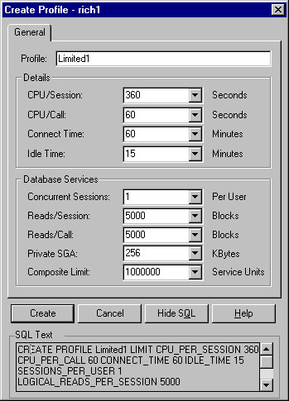
CREATE PROFILE Limited1 LIMIT CPU_PER_SESSION 360 CPU_PER_CALL 60 CONNECT_TIME 60 IDLE_TIME 15 SESSIONS_PER_USER 1 LOGICAL_READS_PER_SESSION 5000 LOGICAL_READS_PER_CALL 5000 PRIVATE_SGA 256 K COMPOSITE_LIMIT 1000000;

Figure: Security Manager – Adding a new profile

Tip: Use profiles to limit ad-hoc query users and/or other users that are typically unpredictable or problematic in their use of system resources.

Tuning Everything - Oracle Expert
Within Oracle’s Enterprise Manager is a utility called the Oracle Expert (version 1.6 in the example covered here) which is focused on tuning from a more global perspective. Oracle Expert automates overall database tuning in three areas: The top 25 instance parameters, indexes (add, drop, modify, rebuild) and structures (sizing, placement, OFA compliance). The DBA selects the scope for the tuning session, then sets up the data collection (which has Oracle Expert collect the data), has the Oracle Expert engine analyze the data and then receives tuning recommendations. Oracle Expert is built on a proprietary rule-based inference engine, which has over 1000 tuning rules, 1/3 of which can be optionally customized by the user. A screen shot of this utility is seen below. Chapter 5 takes a detailed look at the utility.

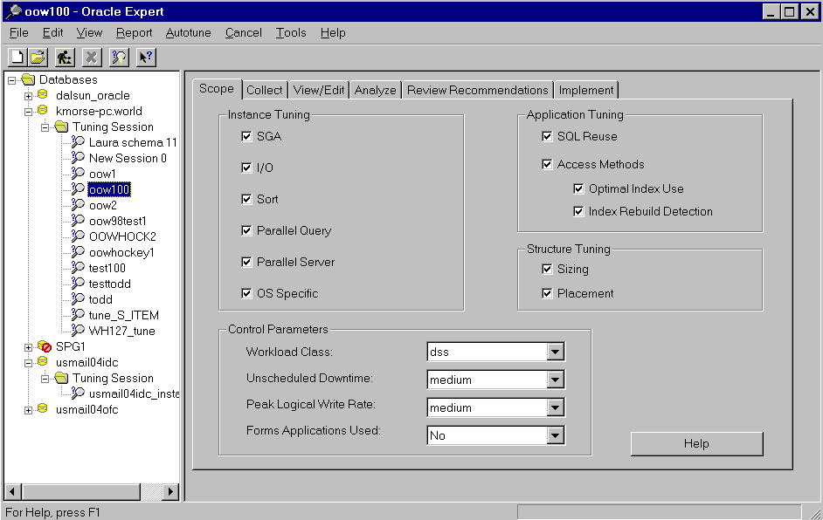

Figure: Performance Pack Oracle Expert Tuning Session

Tip: Oracle Expert looks at the entire database system for areas requiring improvement.

Tuning Using Simple Mathematical Techniques
This section (which is covered in detail in Chapter 9) discusses some simple but effective mathematical techniques you can use to significantly improve the performance of some Oracle SQL-based systems. These techniques can leverage the effectiveness of Oracle performance diagnostic tools and uncover hidden performance problems that can be overlooked by other methods. It also makes it easier to make performance predictions at higher loads. This section was provided by Joe A. Holmes. I am extremely grateful for his contribution as I believe it ties all of tuning together.
The methodology, called Simple Mathematical Techniques, involves isolating and testing the SQL process in question under ideal conditions, graphing the results of rows processed versus time, deriving equations using simple methods (without regression), predicting performance, and interpreting and applying performance patterns directly to tuning SQL code.

Simple Quadratic Equation Determination

The following is a simple three-point method for determining a quadratic best performance equation:

y = a0 + a1x + a2x2

This equation can be calculated for any query using the techniques detailed in Chapter 9 of the book so that you can retrieve one of several possible graphs for a given query. Consider some of the graphs in the figure below and problems that are detailed in the table which follows.

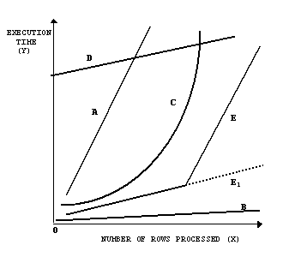

Pattern in Figure 3 | Possible Problem | Possible Solution
A | Missing Index on a query SELECTing values | Create an index. Fix a suppressed index
A | Over-indexed table suffering during an INSERT | Delete some of the indexes or index less columns (or smaller columns) for the current indexes.
B | No Problem. | Don’t touch it!
C | Missing Index on a query SELECTing values | Create an index. Fix a suppressed index
C | Over-indexed table suffering during an INSERT | Delete some of the indexes or index less columns (or smaller columns) for the current indexes.
D | Doing a FULL table scan or using the ALL_ROWS hint when you shouldn’t be. | Try to do an indexed search. Try using the FIRST_ROWS hint to force the use of indexes.
E | The query was fine until some other limitation (such as disk I/O or memory) was encountered. | You need to find which ceiling that you hit to cause this problem. Increasing the SGA may solve the problem, but this could be many things.

Pattern Interpretation
Graphical performance patterns provide clues to underlying SQL problems and solutions. Our ultimate goal in using these methods is to convert a steep linear or quadratic best performance line to one that is both shallow and linear by optimizing the SQL process. This may involve experiments with indexes, TEMP tables, optimizer HINT commands, or other methods of Oracle SQL performance tuning.
With pattern interpretation, it is important to do your own application specific SQL experiments to develop an expertise at using these methods. The following are more specific interpretations based on my personal experience that provide a basic idea of how to apply what is observed directly to tuning SQL code. Provided the scale is correct, pattern interpretation will often provide a more accurate picture of what is actually happening to a process and may support or even contradict what a diagnostic tool may tell you.
An upward sloping (concave) quadratic curve almost always indicates a problem with the process because, as more rows are added the time to process each additional row increases. If the sloping is very small, the equation may be more linear. However, a very slight bowing may be an indicator of something more insidious under much higher volumes.
In rare cases a quadratic curve might appear downward sloping (convex) indicating a process where as more rows are added the time to process each additional one decreases, i.e. economies of scale. This is desirable and may occur at a threshold where a full table scan is more efficient than using an index.
Tip: If you want an Oracle symphony as great as Beethoven’s, you must learn and know how to apply mathematical techniques to your tuning efforts. You don’t have to learn everything that you learned in college calculus, simply apply the simple equations in this chapter to tie everything in this book together. Thank you Joe Holmes for doing the math for us (detailed with examples in Chapter 9 of the book)!

Niemiec’s 7 Rules of Tuning:
Rule 1: The level of tuning achieved can be directly attributable to the number of straight hours that you can work and how much junk food is available.
Rule 2: The level of tuning achieved is tremendously increased if user input is solicited and those users are NOT of the type that try to be politically correct (i.e. You need users that are not afraid to say that this report runs horribly!).
Rule 3: The level of tuning achieved can be directly attributable to the security access to the system that the tuning professional has.
Rule 4: The level of tuning achieved is severely hampered by the level of theoretical knowledge required by the tuning professional.
Rule 5: The level of tuning achieved is severely hampered by the amount of time that a manager is present.
Rule 6: The level of tuning achieved by the number of keyboards, terminals, monitors and PC’s that are within the reach of the tuning professional.
Rule 7: The usual attributes of a good tuning professional (outside of actual performance) can usually be spotted by the person who; calculates the shortest line at McDonalds; calculates the most efficient method for getting each task done yet still leaves at 1am; has coupons for every pizza place that stays open 24 hours at their desk; tends to use twice as much coffee grounds when making the coffee or uses caffeine enhanced water when making the coffee; asks if you would like to go to lunch when it is time for dinner; answers email with a single or half sentence (never a paragraph); has an occasional triple digit weekly hours reported; has no time to be political; and when they have one hour left to go with a problem, you can guarantee that you better multiply by at least four.

Tuning Summary:
Since a single query or a poorly setup INIT.ora can bring system to its knees, the key to tuning often comes down to how effectively you can tune the database memory and also those single problem queries. You must remember to tune both the INIT.ora parameters as well as the actual queries. To tune effectively, you must know your DATA since your system is UNIQUE. You must adjust methods to suit your system. A single index or a single query can bring an entire system to a near standstill. Find those queries with v$sqlarea!

References:
Performance Tuning Tips and Techniques; Richard J. Niemiec, Oracle Press: ISBN: 0-07-882434-6
Chapter 1 | Over A Decade of Tuning Experience
Chapter 2 | Basic Index Principles
Chapter 3 | Disk I/O and Fragmentation
Chapter 4 | Tuning the init.ora
Chapter 5 | Enterprise Manager and Tuning Pack
Chapter 6 | Using explain plan, trace, and tkprof
Chapter 7 | Basic Hint Syntax
Chapter 8 | Query Tuning
Chapter 9 | Table Joins and Other Advance Query Tuning
Chapter 10 | Using pl/sql to Enhance Performance
Chapter 11 | Using Parallel Feature to Improve Performance
Chapter 12  Chapter 13 | Oracle8 New Feature Example  Oracle8 and 8I New Tips
Chapter 14 | The v$ Views
Chapter 15 | The x$ Tables
Chapter 16 | Using and Interpreting ultestat/ultbstat
Chapter 17 | Performing a Quick System Review
Chapter 18  Appendix A  Appendix B  Appendix C | Monitor the System Using unix Utilities  All of the undocumented and documented INIT.ora parameters.  All of the Oracle7 & Oracle8 V$ views and creation scripts from the x$ tables.  All of the Oracle7 & Oracle8 x$ tables

Performance Tuning; Now YOU are the Expert, Undocumented Index Suppression, Rich Niemiec, TUSC; 1991

Special Thanks to:
Brad Brown, Joe Trezzo, Burk Sherva, Jake Van der Vort, Greg Pucka and the TUSC Team who have all made contributions to this document. Dave Kaufman and Mike Henderson for help in the INIT.ORA section of this article

About the Author:
Richard J. Niemiec is the Executive Vice President of The Ultimate Software Consultants (TUSC), a Lombard, Illinois based database consulting company. TUSC specializes in the full cycle of database development including Business Modeling, Design, Development, Implementation and Support. Richard has been giving lectures and presentations on Oracle for the past 8 years and is the current President of the Midwest Oracle Users Group (MOUG). Rich can be reached at TUSC at (630) 960-2909 (niemiecr@tusc.com or visit our web site for more papers at www.tusc.com ).
Please report errors in this article to TUSC. Neither TUSC nor the author warrant that this document is error-free.

