So Many Indexes, So Little Time
Julie Speaker
BMC Software, Inc.

What do indexes do?
Fast access path to table data

Logically and physically independent from data

Drop an index without affecting the table or other indexes

Affect only speed of execution
Indexing Varies With Application Lifecycle

More data

Data characteristics evolve

Users become more sophisticated

Users settle into pattern

Application itself is modified
So Many Indexes

Standard

Partitioned

Bitmap

Index Organized Table (IOT)

Reverse

Cluster
Standard Index
Positive

Reliable, well understood

Analysis tools available

Negative

Can take up more space than the table

Faster access methods

Standard Index Two Step Lookup

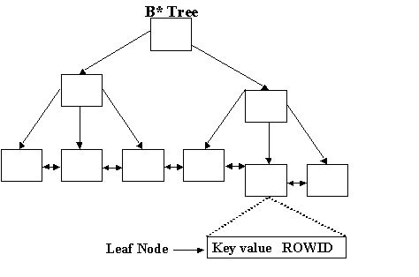
Standard Index Structure
No Indexes?
Full table scan may work so keep an open mind

Ad hoc queries

Cannot predict appropriate indexes

Data mining applications

Multi-row fetch may rival two step lookup

Save space

No index maintenance

Performance may not be critical

Partitioned Indexes

Set of indexes each in own segment

Each partition has its own storage characteristics

Each partition managed separately

Can take a single partition off-line

Access to other partitions is undisturbed
Partitions Give Fast Access

Minimizes index contention

Partition elimination means look in only one partition to find Rowid

Examine key value

Determine correct index partition

Goto a single index partition for Rowid lookup
Types of Partitioned Indexes

Local

Partition divisions match those of the table

Same number of partitions

Same key ranges on table and index

Global

Partition do not match table

Table may be non-partitioned

May partition on a different key than table
Local Partitioned Index
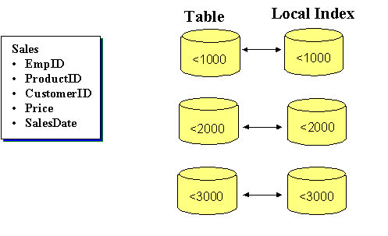
Partition Table on ProductID

Global Partitioned Index
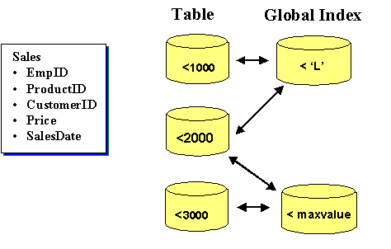
Partition on CustomerID

Oracle8 Partition Division
Range of partition key values

Choose a partition key or keys

Specify a value range for each partition

Take care with boundary values

Range is less than the indicated value

Range value itself is in the upper partition

Can partition on character values
Oracle8i Partition Division
Hash

Uses hash value of partition key to place row

Avoids contention

Lose some ease of maintenance

Composite

Combines range and hash

Partitions divided by range, then hashed

Most useful

Partition Candidates
Index candidates

Large indexes

Fast access required

Ease of maintenance

Load data in batches

Data characteristics

Few restrictions
Bitmap Indexes

Store column values as a bit string

Each bit corresponds to a table row

One bitmap for each distinct value of the column

Bit is zero or one depending on column value
Bitmap Index Concept

Bitmap Index Structure
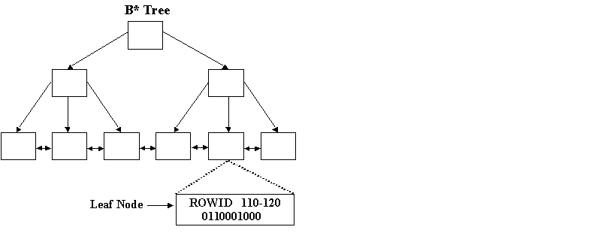
Bitmap Cardinality

Low number of distinct values per column

Consider a table with 1 million rows

10,000 distinct values is low

500,000 distinct values rivals standard index

Do need minimum of 2 rows per value

Guideline is 100 rows per distinct value
Fast Bitmap Joins

Limits set of candidate rows before table is accessed

Combining bitmaps is fast

Applicable SQL clauses

Where predicates

Equal, not equal, and, or

Between, in

Group by

Distinct
Building Bitmaps

Control the amount of memory allocated for bitmap creation

CREATE_BITMAP_AREA_SIZE

Default of 8M

Increase size as distinct values increase

Larger area size may build faster

May be partitioned local index
Maintaining Bitmaps

Easy to change row to an existing distinct value

Flipping a bit in two bitmaps

Expensive to add new distinct value

Build a new bitmap

Expensive to add or delete rows

Affects each bitmap for the column

Rearrange leaf node values
Bitmap Candidates
Column examples

Gender

SalesMonth

SalesPersonID

PurchaseOrderID in purchase order line item table

Data characteristics

Stable number of rows

Stable set of distinct values
Index Organized Table (IOT)

Combines a table and its index into one structure

Faster access because does not use Rowid lookup

Saves space

Only one database object

Does not store Rowid

IOT Concept
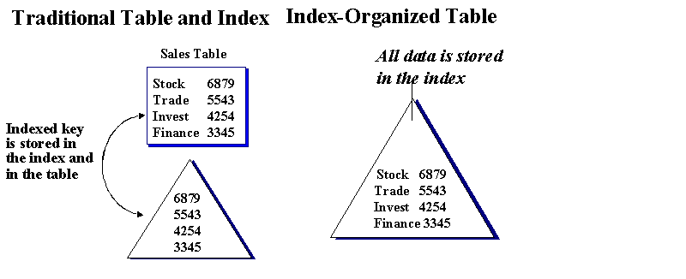
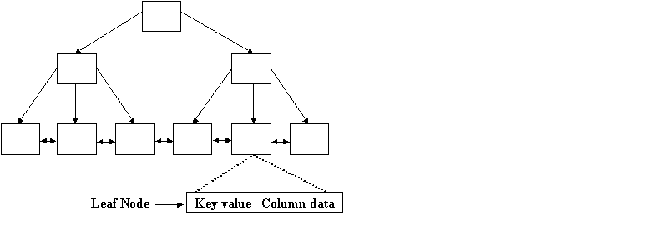
IOT Structure

IOT Overflow Table

Holds long rows

Exceed the length storable in the IOT leaf

Exceed a threshold value

Two step data lookup

Create overflow table in IOT DDL
Use of Rowid in an IOT
IOT rows do not have permanent location

No Rowid means no standard indexes on an IOT

Restriction removed in O8i

Uses a pseudo-Rowid which may not be accurate

Allows building secondary indexes against IOT

Physical guess potentially slows access

Take care in designing secondary indexes
Building and Maintaining IOTs

Maintenance much like standard index

May be partitioned

DBMS_IOT package

Builds exception table

Builds chained_rows table for statistical analysis
IOT Cautions

Mostly static data

More robust than bitmaps

Cannot be replicated

For fast access, avoid overflow tables

For smallest size, avoid secondary indexes
IOT Candidates
Table examples

Cross reference tables

Code descriptions

Inverted indexes

document keywords, spatial data

Data characteristics

Row is mostly key columns

Row may contain LOBs but no LONGs
Reverse Index
May reduce contention for insertion into same set of leaves

Standard index

Byte order of key columns is reversed

Order of key columns is preserved

Lose ability to scan by range of key values

Reverse Index Concept
Reversing Concatenated Keys
Byte order of single key column is reversed

YYYYMMDD reverses to DDMMYYYYY

19990415 reverses to 51409991

Order of key columns is preserved

Year|Month|Day to rYear |rMonth | rDay

19990415 to 99914051
Reverse Index Candidates
Primary key examples

Sequential IDs

Timedate stamps

Constructed dates

Data characteristics

OLTP

Frequent access to narrow range of keys

Consider hashed partitioned index
Cluster

Method to store and retrieve data

Hash access uses no index

Static data grouped as related tables

Data warehouse

Scientific data

Time series
Which index is best for me?

Standard

Partitioned

Bitmap

Index Organized Table (IOT)

Reverse

Cluster
Index strategies 1
To save space

Bitmap

IOT

Cluster

Full table scan

For easier maintenance

Local partition

Standard
Index Strategies 2
For faster retrieval

Partition

IOT

Bitmap

To minimize contention

Partition

Reverse
Index Strategies 3
For dynamic data

Standard

Reverse

Partition

For static data

Bitmap

Cluster

IOT (can be updated)
Further Information

Ensor and Stevenson Oracle Design O’Reilly 1997

Ensor and Stevenson Oracle8 Design Tips O’Reilly 1998

Oracle Technical White Paper Oracle8 Indexing Strategies 1997

Oracle Technical White Paper Taking Advantage of Partitioning in Oracle8 1997

Oracle Technical Report Bitmap Indexes Oracle 7.3 and 8.0 1997

Thank you

